***HARD DISK PARTITIONS USING GPARTED***

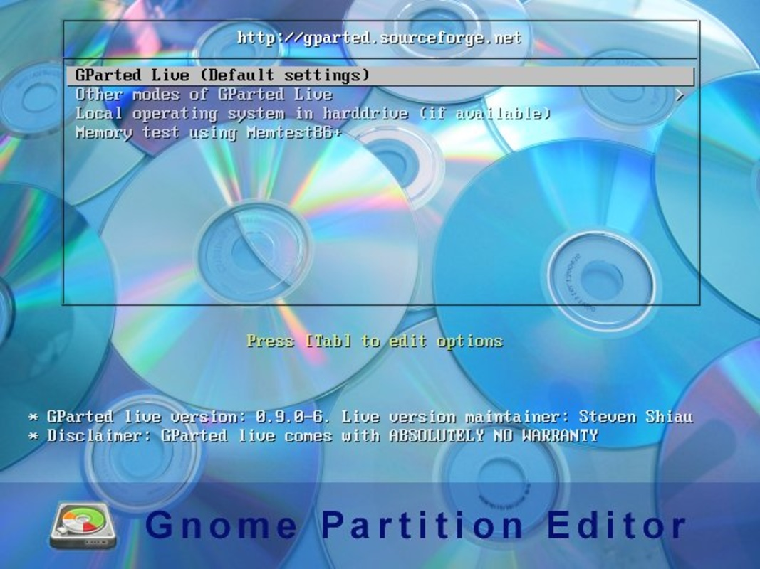

Ana Cifuentes Romero

DW1E - 10/10/21021

INDEX

1.-Introduction2

2.- DRBL-LIVE installation3

3.- GPARTED: partitions. 5

4.- Hard Drive partitions on Windows:

1) A NTFS primary partition of 2GB called PNTFS 6

2) An EXT4 primary partition of 2GB called PEXT4 7

3) An extended partition of 4GB 7

4)A logical partition of 2GB called PFAT32 8

5.- ANSWER THE FOLLOWING QUESTIONS:

1) Why is the file system not showed in the second partition? 9

2) If you had to create a new partition to store 2 GB data, where would you put the partition in? Which file system should you use? Justify your answer 9

**1.- Introduction.**

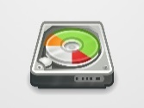Partitions are logical pieces of hark disk space, defining the size and the file system format for the operating system and data that are going to be placed on them. Disk partitioning is the creation of one or more regions on a hard disk or other secondary storage, so that an operating system can manage information in each region separately.

One of the most important basic aspects of mastering your operating system is being able to control the partitions. If you want to manipulate the layout, create it, change it, or delete it, you can adapt your software to your varying needs. In order to do that, you may use GPARTED, one of the most popular partitioning software.

GPARTED is a graphical software, so it is well suited for modern use and comes included with most modern Linux distributions. This software can be used in two ways: while booted in an operating system or from a live CD. The recommended way of using GPARTED is form live environment because partitioning operations need to be done on hard disk when they are not in use, to avoid data corruption.

Another important information is that partitions are in used cannot be modified because they are locked by the operating system that uses them. So, partitioning can be done only when the hard disk partitions are unmounted.

It is always the best idea to handle partitioning from live CD environment. Nowadays, almost all Linux modern distributions are sent as a bootable live CD. And it also allows you to perform maintenance operations from the live environment.

To sum up, the most important ideas about the uses of partitions are three:

* Partitioning software cannot be used on partitions that are used (mounted) by an operating system.
* Partitioning software can be used on system partitions only when booted in a live CD environment.
* Partitioning software can be used on data partitions or empty, non-system disks while booted in either local, installed operating systems or from a Live-CD environment.

As I said above, we need to install a live CD, and this software is DRBL-LIVE (Diskless Remote Boot in Linux). It is a free software, open-source solution to managing the deployment of the GNU/Linux operating system across many clients.

The project is based on an idea that consists of loading and booting from a server the operating system that is going to run on multiple machines. All you must do is manage the Operating System image from the server.

In this way, we will be able to coexist multiple Operating System in a single machine, the same system installed in the machine will be able to share resources with the System loaded from the server.

In these exercises we just need to use and learn how to handle the hard disk partitions of different operating systems.

**2.- DRBL-LIVE installation.**

In this case, I want to use a Windows 7 Operating System and the first thing we must do is to create a new hard disk for the virtual machine. The screen below shows the actual storage.

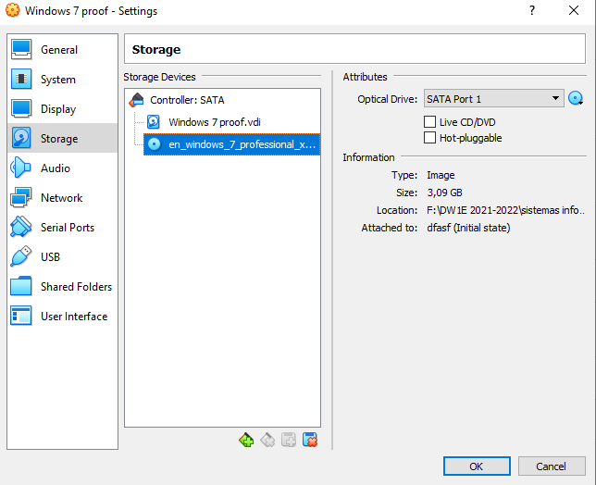

Now, we need to create a new 10 GB hard disk from **Settings-> Storage->Controller: SATA->Adds Hard Disk**. After that we wil choose the LiveCd from “Attributes”-> “Optical Drive”->drbl-live image and then start it. Then click on **“OK”** button.

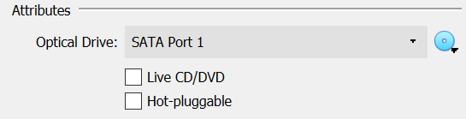

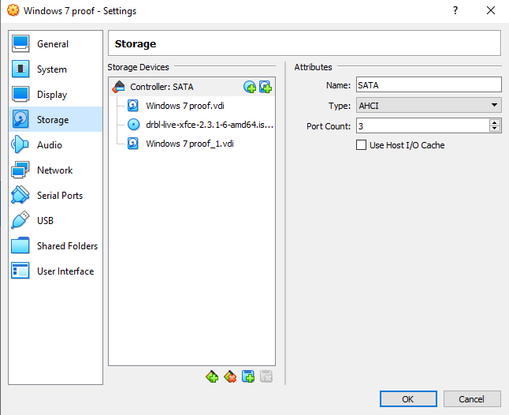

This is the main screen in which we can choose among several options. In this case, we need the first one and click on it.

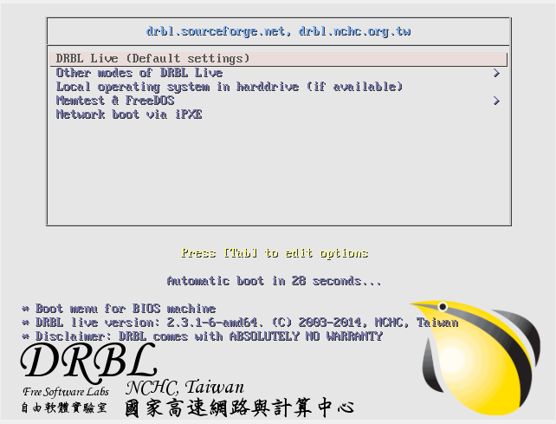

After that, we choose English language in order to work properly with our subject in English and careful with the placement of **special characters** on the keyboard because ours is in Spanish and the order is different. Then press **“Enter”.**

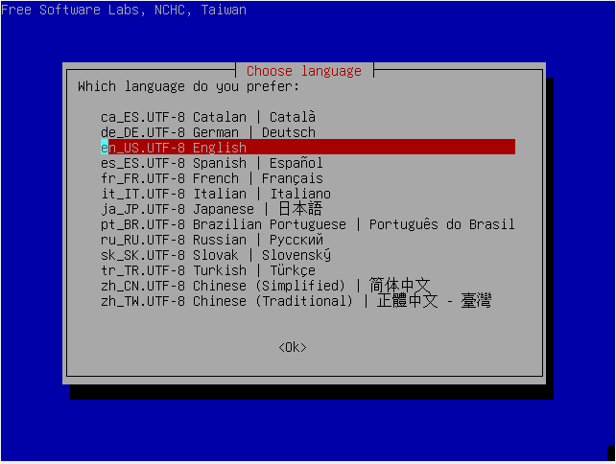

Then, it will ask us about the character map that the program will use, by default let us **“Don’t touch the map”**. And we continue.

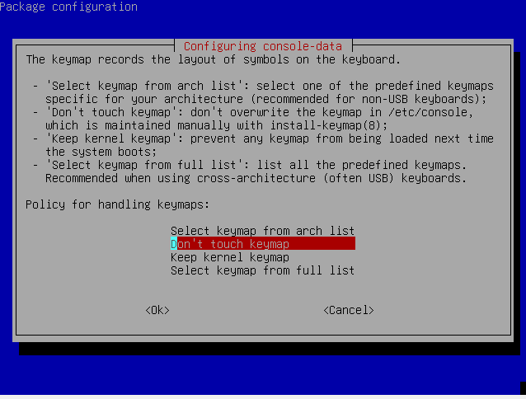

Finally, the program will inform us about how we want the graphical mode (we choose number one), screen resolution (we choose number seven) and the driver VGA card type (enter). For the rest questions, we press **“Enter”**.

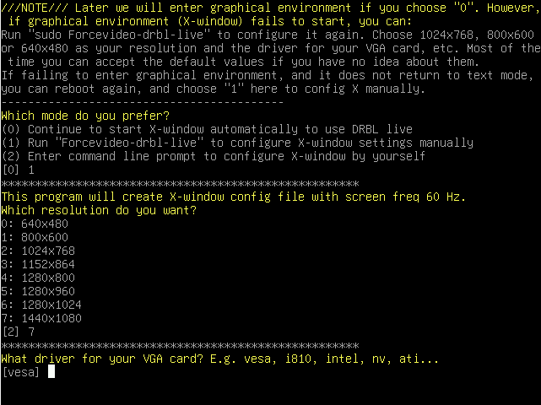

**3.- Gparted: partitions.**

This is the DRBL-LIVE home screen, and as you can see in the lower left there is GPARTED icon which we will use to format the new hard drive.

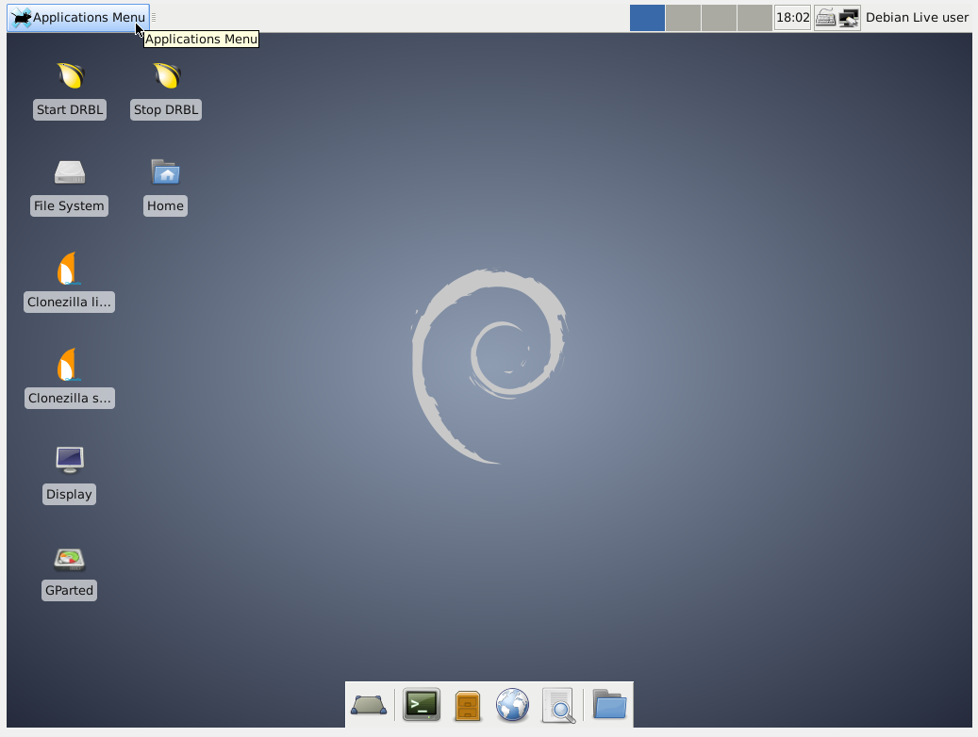

GParted displays the first device only by default. But if you want to work on the second hard disk you must switch clicking in the right corner above the colour bar where there is a **drop-down button** which allow you to change visible devices.

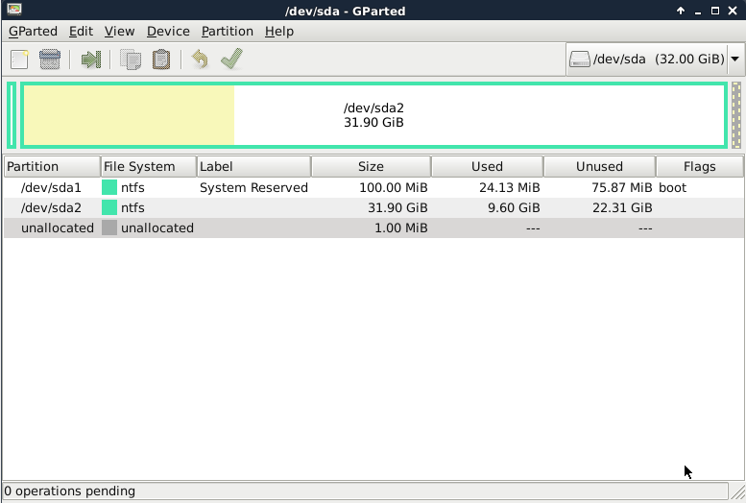

This is the second hard disk partition of our Windows 7 on which we want to add partitions and format. First thing we must do is to create a partition table**: click “Menu->Device->Create Partition Table”** and, in order to make Windows 7 hard drive partitions, we select **msdos**. Then click on **“Apply”** button.

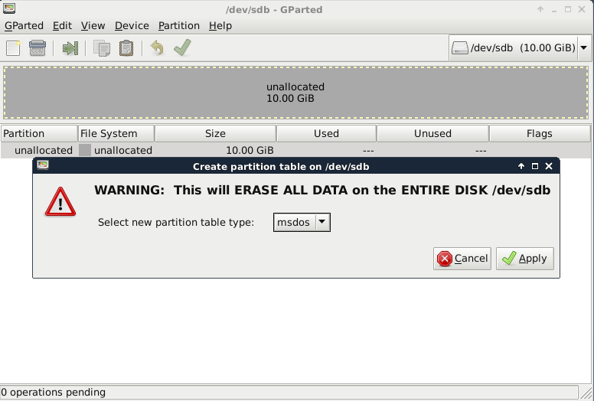

**4.- Hard Drive partitions on Windows.**

1. **A NTFS primary partition of 2GB called PNTFS:** Now is ready for new partitions. Over the partition space, click the right mouse button and select “Create new Partition” on which you can change size, type of partition, file system and even move partition the place you can set up it, clicking on **“Menu->Partition->Resize/Move”**. Primary Partition (you can create 4): ntfs (New Technology File System Replaced FAT on Windows Systems), 2GB and PNTFS name. Then click on **“Add”** button to create it.

|  |  |
| --- | --- |
|  |  |

1. **An EXT4 primary partition of 2GB called PEXT4:** The second partition has the same size 2GB, is also a Primary Partition, file system ext4 (fourth extended filesystem used by many Linux distributions. Extends storage limits) and PEXT4 name. Then click on **“Add”** button to create it.

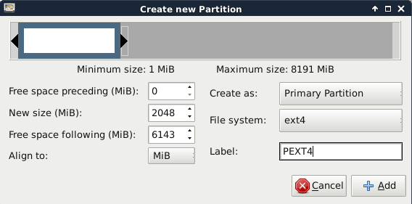

1. **An extended partition of 4GB:**  The third partition is not a data contained, acts as a container (the idea is the idea is to have more than four partitions on a hard drive) for logical partitions and we will create the Extended partition in order not to waste the few primary partitions we have. We can use them we can use them to store data or to create logical partitions within them.

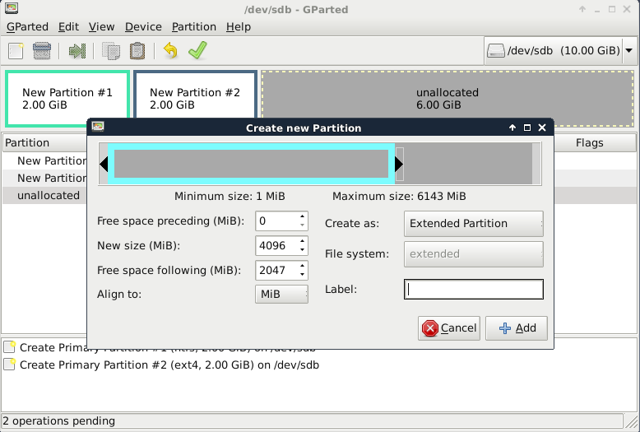

1. **A logical partition of 2GB called PFAT32:** The last one is a partition that are made within an extended partition. All you will need is to assign a size, file system, type, and it will be ready to be used. They work as if they were separate devices, and you can use it to store any file. You must create it right-clicking on the partition, choose “New”. Then click on **“+Add”** button.

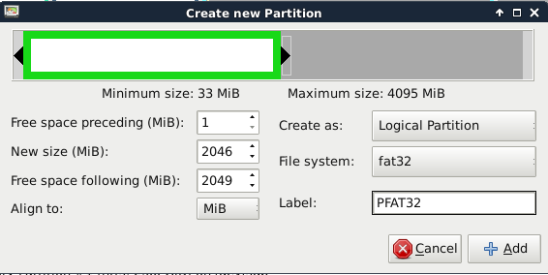

Finally, before committing the changes, we If you want to change the filesystem chosen for any which partition, you can do it without deleting the partition and creating a new one instead. You can simply format it with the new filesystem you desire by right clicking on the partition and choose **“Format to”**. If you do not need to change the filesystem chosen, click **“Apply”** button in order to apply all operations.

|  |  |
| --- | --- |
|  |  |

Once these steps are finished, we need to start Windows 7 to check in **Disk Management** if the same result is shown. First, we change the Optical disk to Windows 7 in order to run this operating system and after that, click on **“Start->Computer->Manage->Disk Management”**.

|  |  |
| --- | --- |
|  |  |

**5.- ANSWER THE FOLLOWING QUESTIONS:**

1. Why is the file system not showed in the second partition?

Because ext4 file system is only used by GNU/Linux distributions, and it can only be used in this operating system family.

1. If you had to create a new partition to store 2 GB data, where would you put the partition in? Which file system should you use? Justify your answer.

If a had to create a new partition to store 2 GB data, I would put the partition inside the Extended partition (container partition), so-called the logical partition in order not to waste the four primary partitions we have and because this type of filesystem has unlimited space, and we can create 23 partitions.

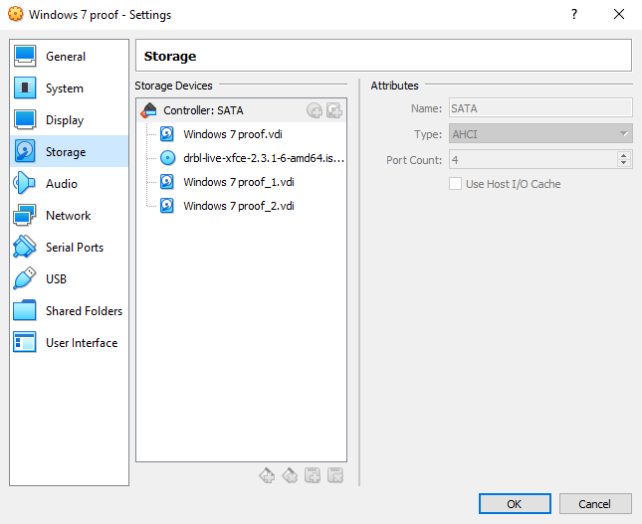

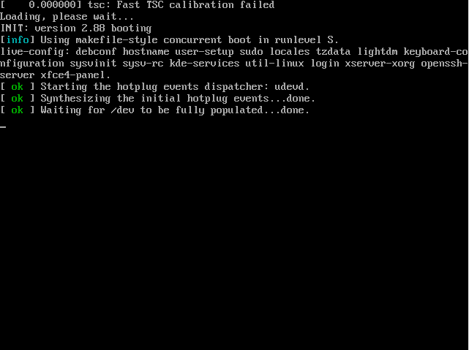

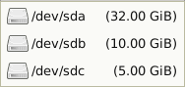

Create Partition Table

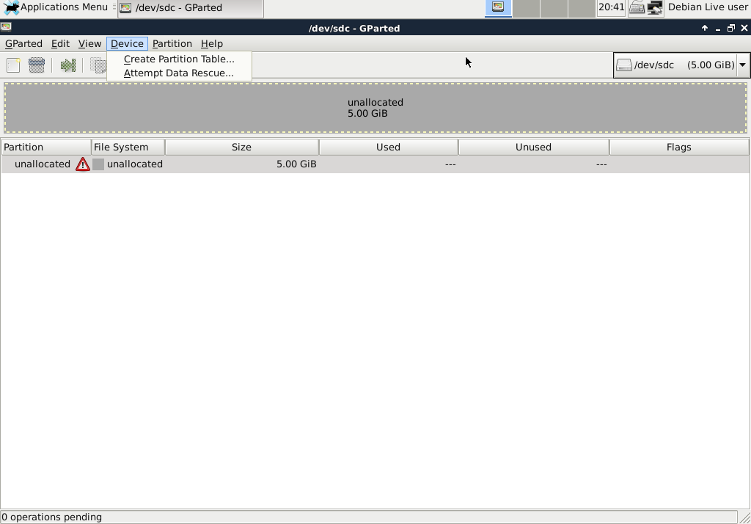

Select Partition Table type

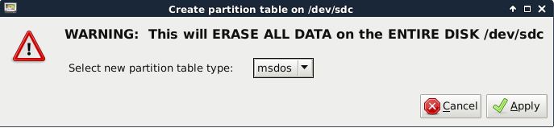

First partition:

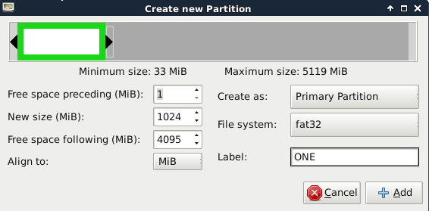

Second partition:

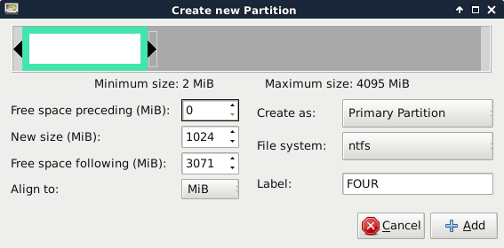

Extended partition 3072:

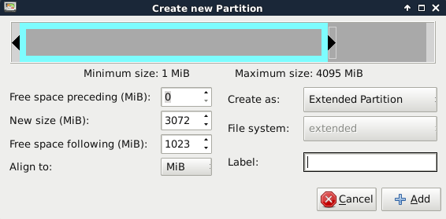

Fourth partition:

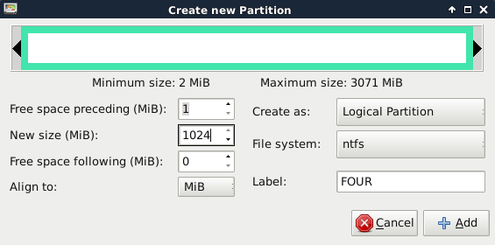

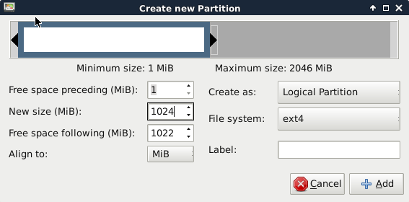

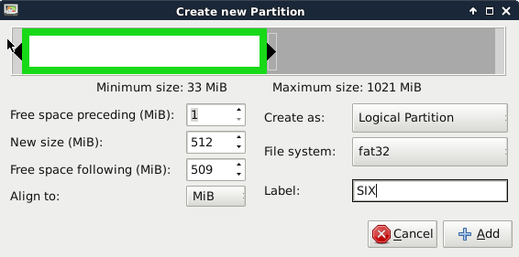

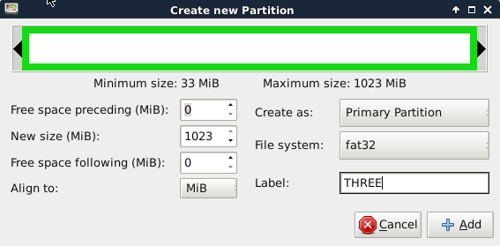

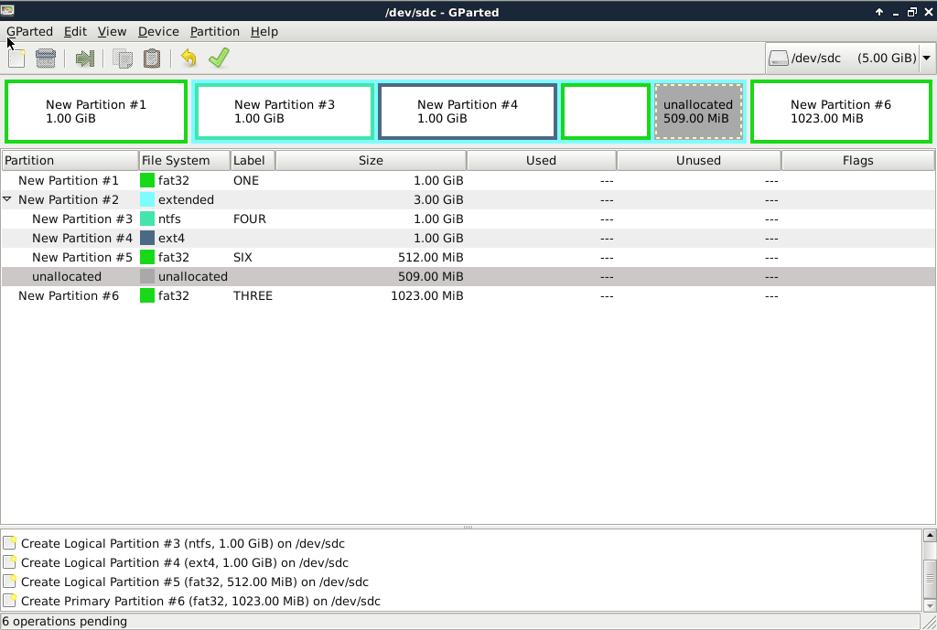

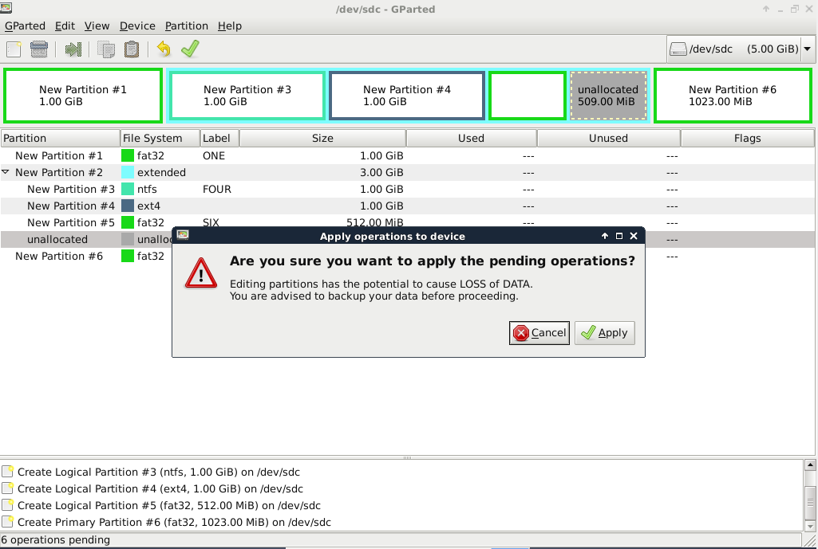

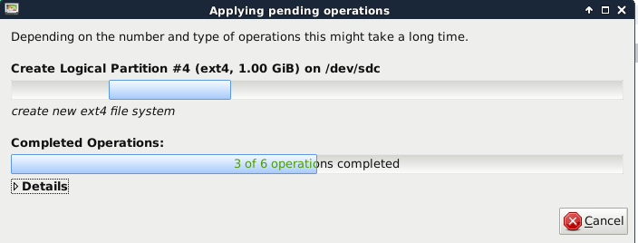

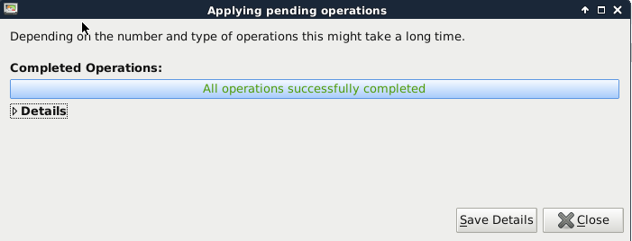

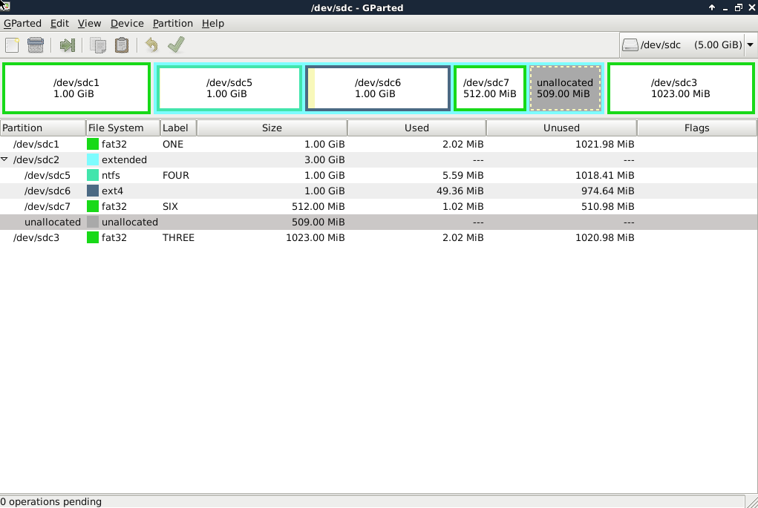

Then shut down drbl

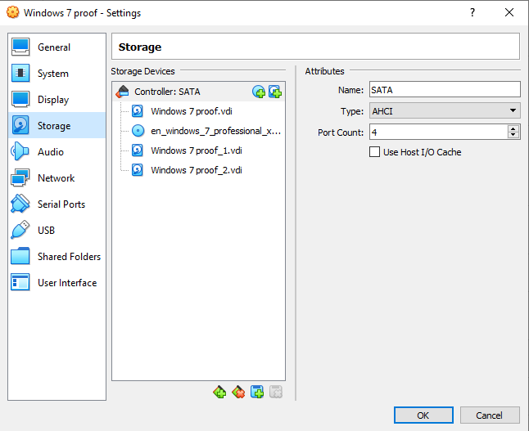

This is the result in Windows 7

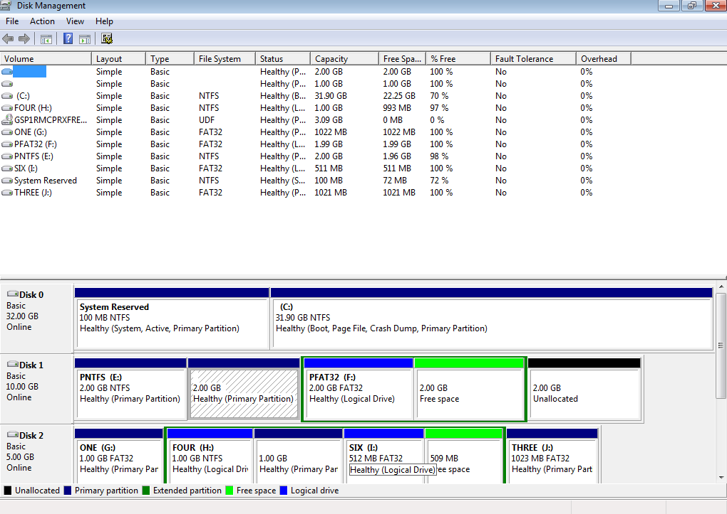

1. How does GParted name the new hard disk?

The name is /dev/sdc. This is the third SCSI device which means is the third hark disk (primary partition).

1. List all the partitions you have created, indicating type and file system.
2. Primary partition, ntfs (Windows).
3. Primary partition, ext4 (LINUX).
4. Extended partition:
5. Logical partition, fat32 (Windows).
6. Logical free space, unallocated.
7. Primary partition, fat32 (Windows)
8. Extended partition:

a) Logical partition, ntfs (Windows)

b) Primary partition, ext4 (LINUX)

c) Logical partition, fat32 (Windows)

d) Logical free space, unallocated.

6) d) Primary partition, fat32 (Windows)

**BIBLIOGRAPHY**

* Hard disk partitions explained:

<https://www.howtogeek.com/184659/beginner-geek-hard-disk-partitions-explained/>

* Required and recommended partitions when installing Ubuntu:

<https://help.ubuntu.com/community/DiskSpace#Separate_.2Fboot_.28sometimes_required.29>

* How to access shared folders in Ubuntu:

<https://www.howtogeek.com/187703/how-to-access-folders-on-your-host-machine-from-an-ubuntu-virtual-machine-in-virtualbox/>

* Gparted Tutorial:

<https://www.dedoimedo.com/computers/gparted.html#mozTocId824187>